Academic Task Number: CA-2 (Test-1) SET-C Course code: ECE-249 Section: K22
Date of allotment: Course title: BEEE Roll No.
Date of submission: Maximum Marks: 30 Reg. No.
Academic Task Type: Subjective
Q. No. | Question Statement | Course Outcome | Bloom’s level | Marks
Q1 | a) State Kirchhoff’s current law (KCL) and Current divider rule with an example.  b) What is maximum power transfer theorem. | CO2 | L1: Remember | 5
Q2 | A sinusoidal voltage supply defined as: V(t) = 120 x cos(ωt + 30o) is connected to a pure resistance of 50 Ohms. Determine its impedance and the peak value of the current flowing through the circuit. Draw the corresponding phasor diagram. | CO1 | L3: Apply | 5
Q3 | a) Define the nodal analysis.  b) Find the node voltages at node 1 and 2.  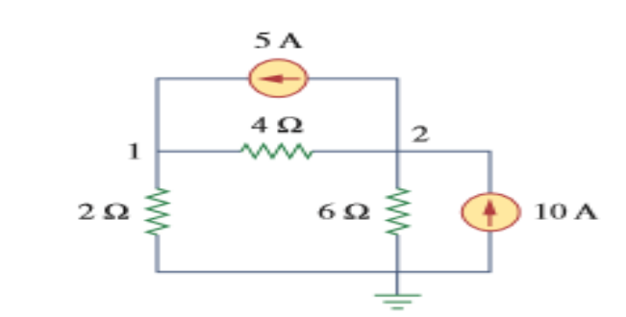 | CO1 | L1:Apply | 5
Q4 | Discuss construction of transformer in brief with appropriate diagram. | CO1 | L3: Apply | 5
Q5 | Find the Norton’s equivalent circuit at the terminal a & b.  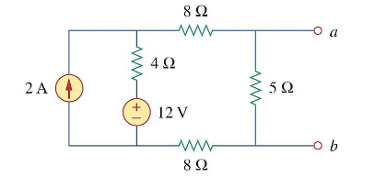 | CO1 | L1:Remember | 5
Q6 | In a series RL circuit,  i(t)= 20 Sin (628t + 100)  v(t)= 15 Sin (628t + 120º)  - Calculate the RMS value of current and voltage?  - Average value?  - Real power?  - Reactive power?  - Apparent power? | CO2 | L3: Apply | 5

